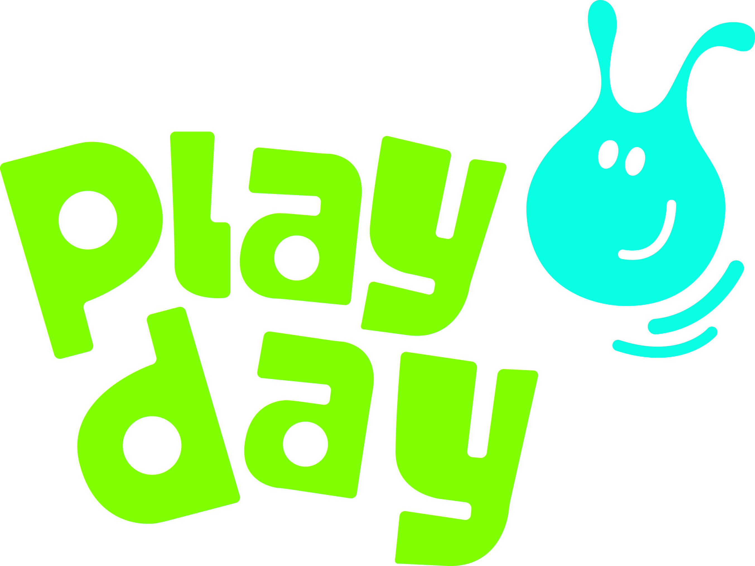
Monday 1 August

Thousands of children play out for #Playday2016

On Wednesday, thousands of children and young people from across the United Kingdom will be out playing, celebrating Playday – the national day for play.

Hundreds of local and regional play events are taking place to promote the importance of children’s right to play.
This year’s Playday theme ‘Play Matters…’ celebrates the many benefits of playing out doors. Many of our childhood memories are reminiscent of climbing trees, making dens, jumping in puddles, making mud pies, rolling down hills, playing with water, chasing, hide and seek, climbing.

It will be no surprise then to learn that when children talk about their preferred play experiences, they more often than not cite outdoor play as their favourite activity. This makes sense; the outdoors is the very best place for children to practice and master emerging physical skills. Frequent and regular opportunities to explore and play in the outdoor environment is essential for children’s holistic health, their well-being, health, happiness, learning and development.

Play England’s Chair of Trustees, Nicola Butler, said: ‘Play is vital for children's mental health and wellbeing. It’s how children make friends, get active and fit, and become confident and competent.’

Play Scotland’s Marguerite Hunter Blair said: ‘Play matters for our children and our communities. Playing is an innate behaviour that also contributes to children’s quality of life, their well-being and their physical, social and cognitive development. Playday offers opportunities for children and families to get out and play in the garden, streets and local neighbourhoods which can help build better relationships across the generations and within the community - so get out and Play on Playday!’

Mike Greenway of Play Wales said: ‘Play matters because it is how children define their lives and learn how they fit in the world. Unfortunately because it’s more fun than school some people think it’s less important; nothing could be further from the truth.’

Jacqueline O'Loughlin of PlayBoard NI said: ‘Play matters because it is important for children’s health, happiness and well-being. Play supports creativity while developing children’s imagination, dexterity, and physical, cognitive, and emotional strength. Through play children from the earliest of ages engage with and interact in the world around them’

- ENDS –
MEDIA ENQUIRIES:
For more information please contact:
Sophie Bolt, Play England’s Communications Officer: 07802 722412
Angharad Jones, Play Wales – 029 2048 6050
Play Scotland – 0131 440 0456 or 07795 954856
PlayBoard Northern Ireland – 028 90803380 or Jacqueline O’Loughlin, CEO on 07709336890

Social Media:
Follow #Playday2016 events on Twitter: https://twitter.com/Playday4Nations
On Facebook:
https://www.facebook.com/Playday-1388566451451801/?ref=hl

NOTES TO EDITORS:
About Playday
Playday is the national day for play, traditionally held on the first Wednesday in August. As well as an annual celebration of children’s right to play, Playday is a campaign that highlights the importance of play in children’s lives. Playday is coordinated by Play England, Play Wales, Play Scotland and PlayBoard Northern Ireland. On Playday thousands of children and young people get out to play at hundreds of locally organised celebrations – from small-scale neighbourhood get-togethers to large-scale public events. For more information see www.playday.org.uk.
About Play England
Play England campaigns for all children to have the freedom and space to play throughout childhood. As the national organisation for children’s play, Play England works with all those who have an impact on children’s lives to support and champion play as an essential part of childhood. For further information or to talk to a spokesperson, call 07802 722412 or visit www.playengland.org.uk.
About Play Wales
Play Wales is the national charity for children’s play in Wales. We provide advice, support and guidance for all those in Wales who have a concern or responsibility for any environment where children and young people might play. Play Wales upholds children’s right to play. All children are entitled to quality play provision within their communities and we work strategically to achieve this goal on their behalf. For further information visit www.playwales.org.uk.
About Play Scotland
Play Scotland was formed in 1998 to make the child’s right to play a reality in Scotland. The work of Play Scotland is underpinned by the United Nations Convention on the Rights of the Child and in particular Article 31: “States Parties recognise the right of the child to rest and leisure, to engage in play and recreational activities appropriate to the age of the child and to participate freely in cultural life and the arts.” Play Scotland’s mission is to increase awareness of the importance of play to the development of children and young people in Scotland; To ensure that all children and young people in Scotland have equal access to diverse and quality play opportunities that meet their individual need. For further information on Play Scotland visit www.playscotland.org or Email: info@playscotland.org
About PlayBoard Northern Ireland
PlayBoard is the leading agency for the development and promotion of children and young people’s play in Northern Ireland. To this end, the organisation provides a range of innovative services designed to strengthen service delivery through advice, support, training and tailored provision
PlayBoard’s work is concentrated and prioritised within a framework of ‘equity, diversity and interdependence’ (EDI), and is consistent with the ethos of human rights, social justice and social inclusion. For further information on PlayBoard visit www.playboard.org or Email: lisa.oconnor@playboard.co.uk

